**LETSUPGRADE AWS ESSENTIALS**

**DAY 2 ASSIGNMENT 1**

# **Question 1**

Create and Manage a Windows instance

1.Choose a windows AMI and create an ec2 instance.

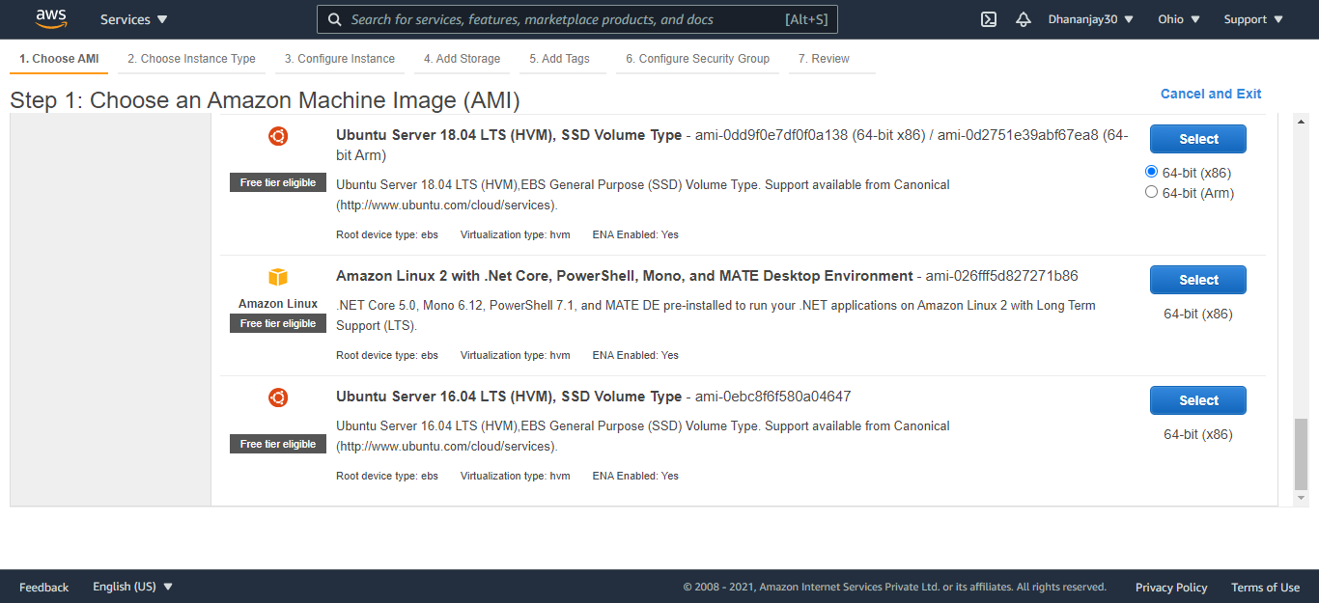

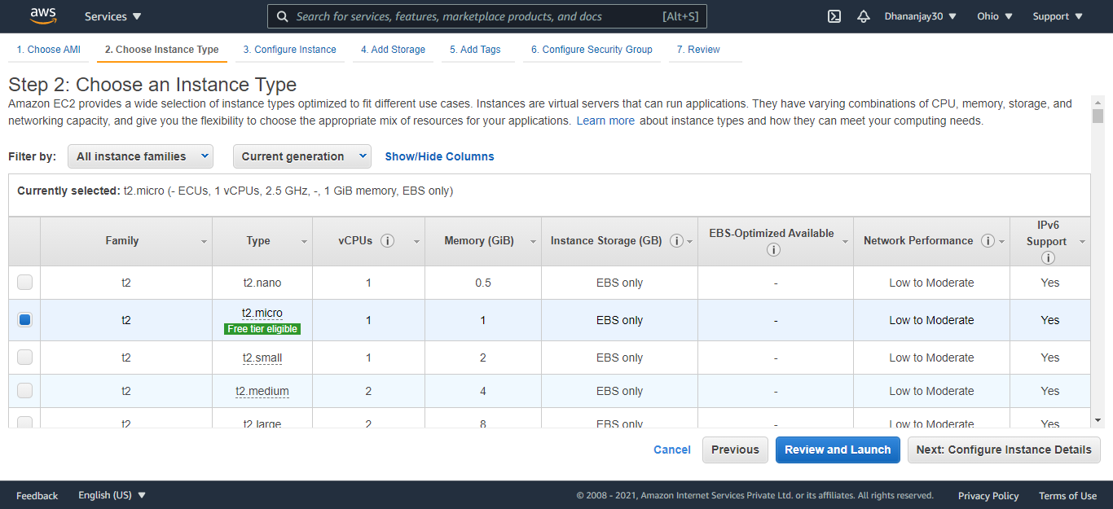

2.Click on connect and move to the RDP client tab.

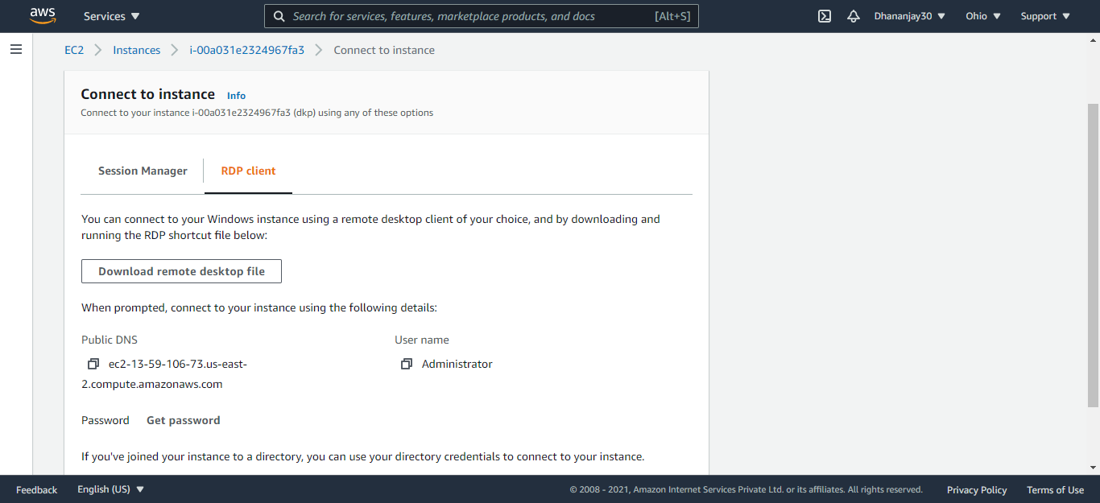

3.Upload key pair file to get the password.

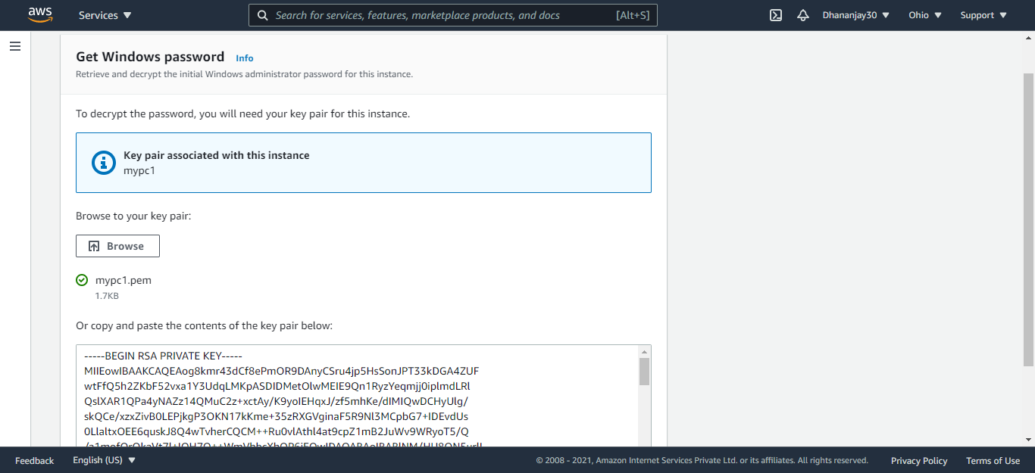

4.Use the password to RDP into the instance.

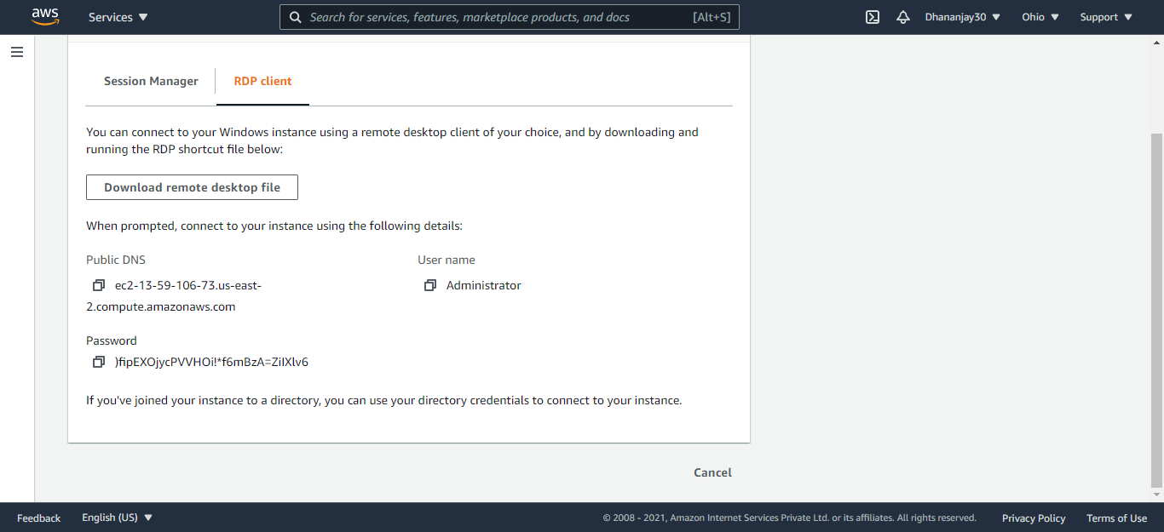

5.Terminate the instance

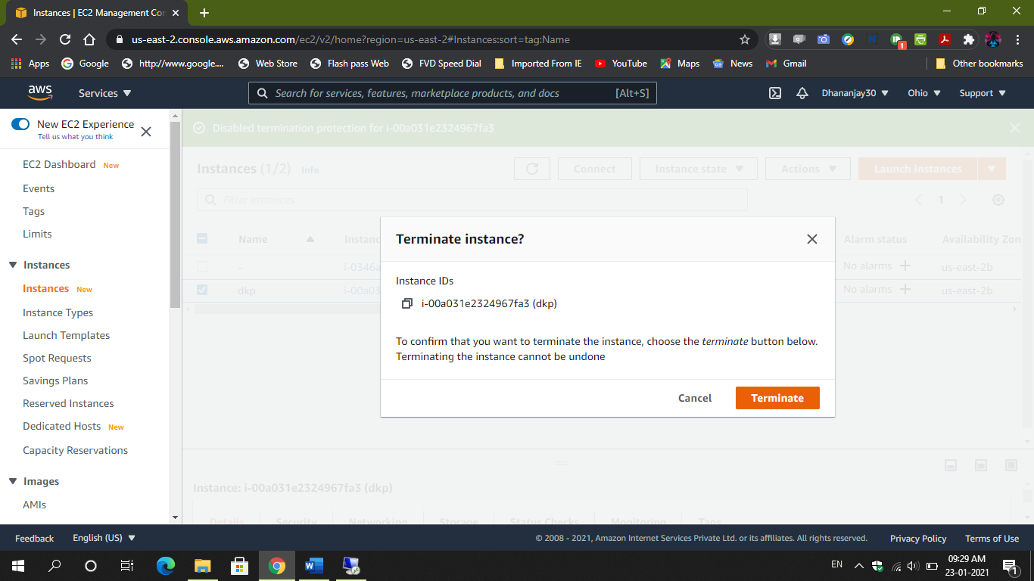

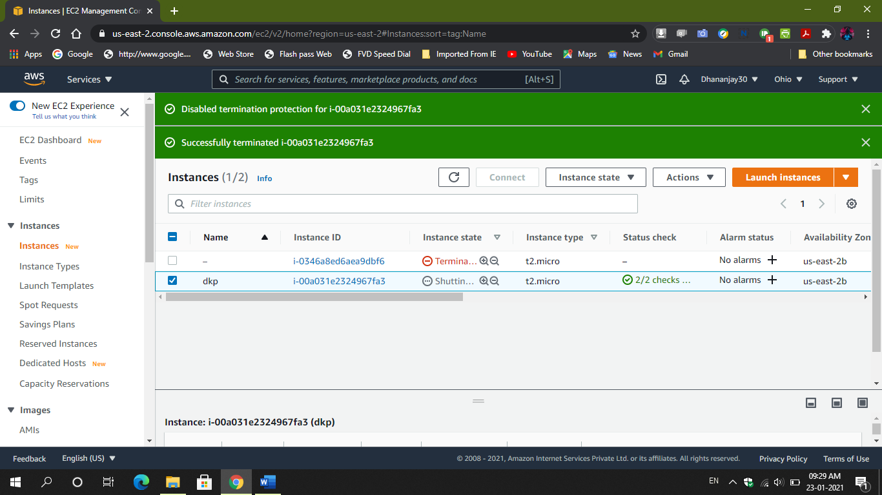

● **SS1:ec2 dashboard with instance listed**

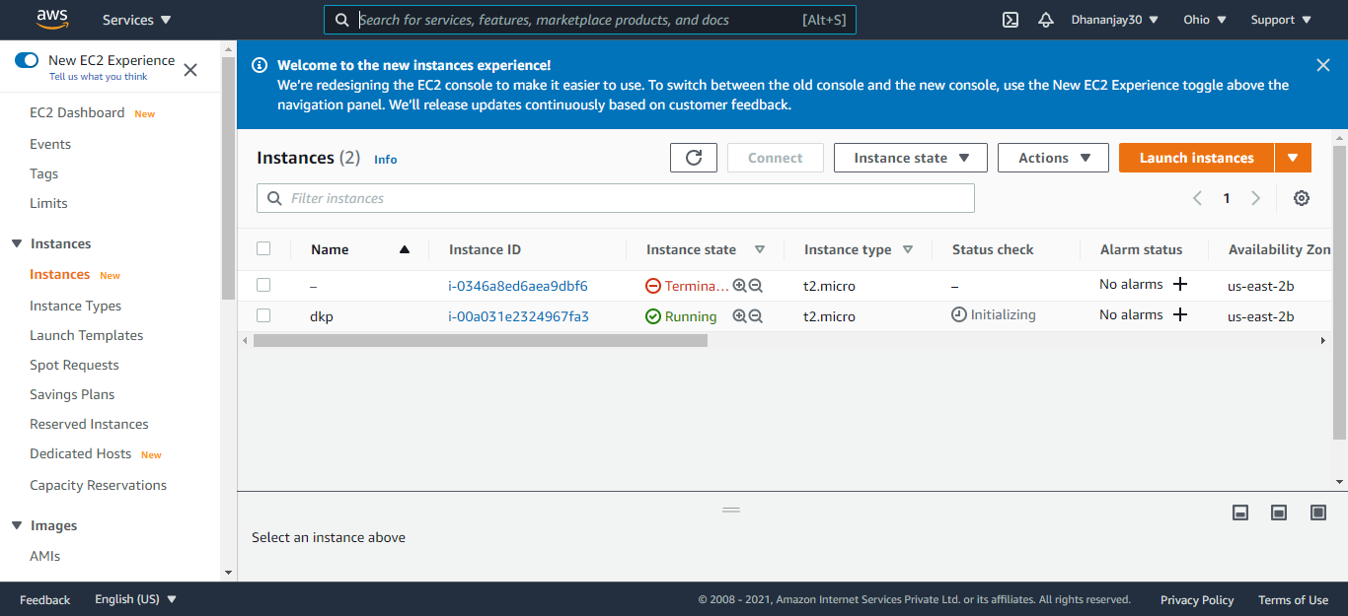

● **ss2:ec2 instance details**

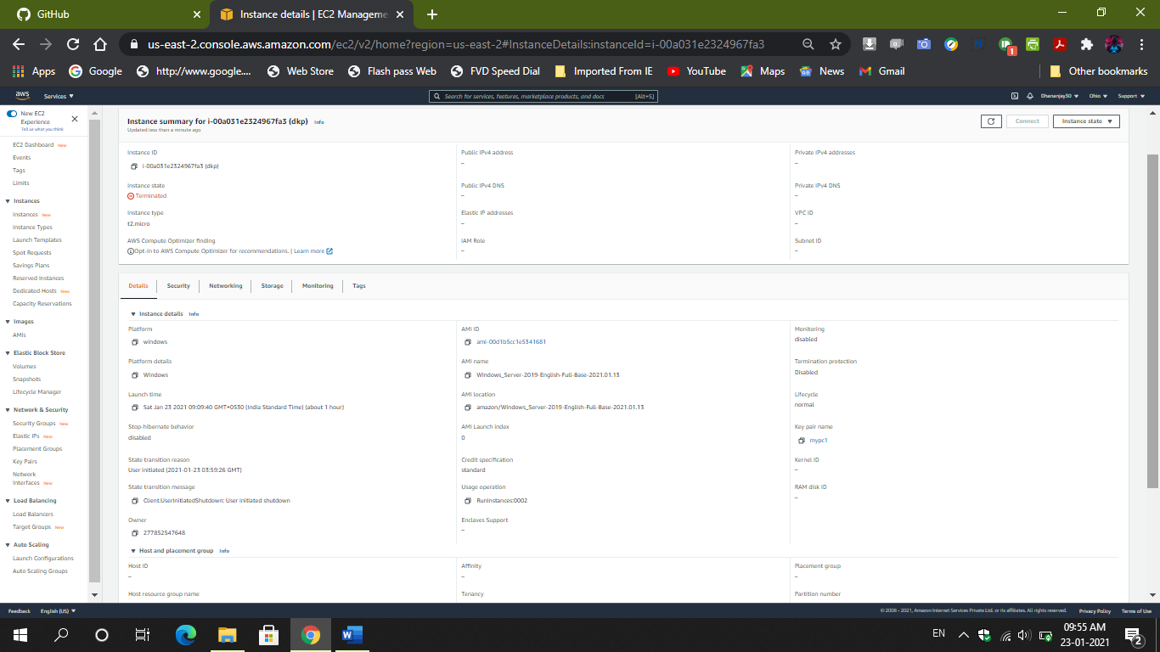

**● ss3: windows screen after the successful launch**

